Basic OF Web Programming

Lab-8

Name : Parmar Rahul J

PRN : 2018033800122455

Roll No : 529

Batch : B

1-Use a jQuery method to toggle between sliding up and down a <div> element, when clicking on a button.

Code:

<!DOCTYPE html>

<html lang="en">

<head>

<meta charset="UTF-8">

<meta name="viewport" content="width=device-width, initial-scale=1.0">

<title>1</title>

<script src="https://ajax.googleapis.com/ajax/libs/jquery/3.5.1/jquery.min.js"></script>

</head>

<body style="margin: 0;padding:0;">

<div style="background: red;width: 100vw;height: 30vh;" id="hi">

</div>

<div style="text-align: center;margin: 20px;">

<button style="text-align: center;" onclick="hello()">Click to Toggle</button>

</div>

<script>

function hello(){

$('#hi').slideToggle(1000,'linear');

}

</script>

</body>

</html>

Output:

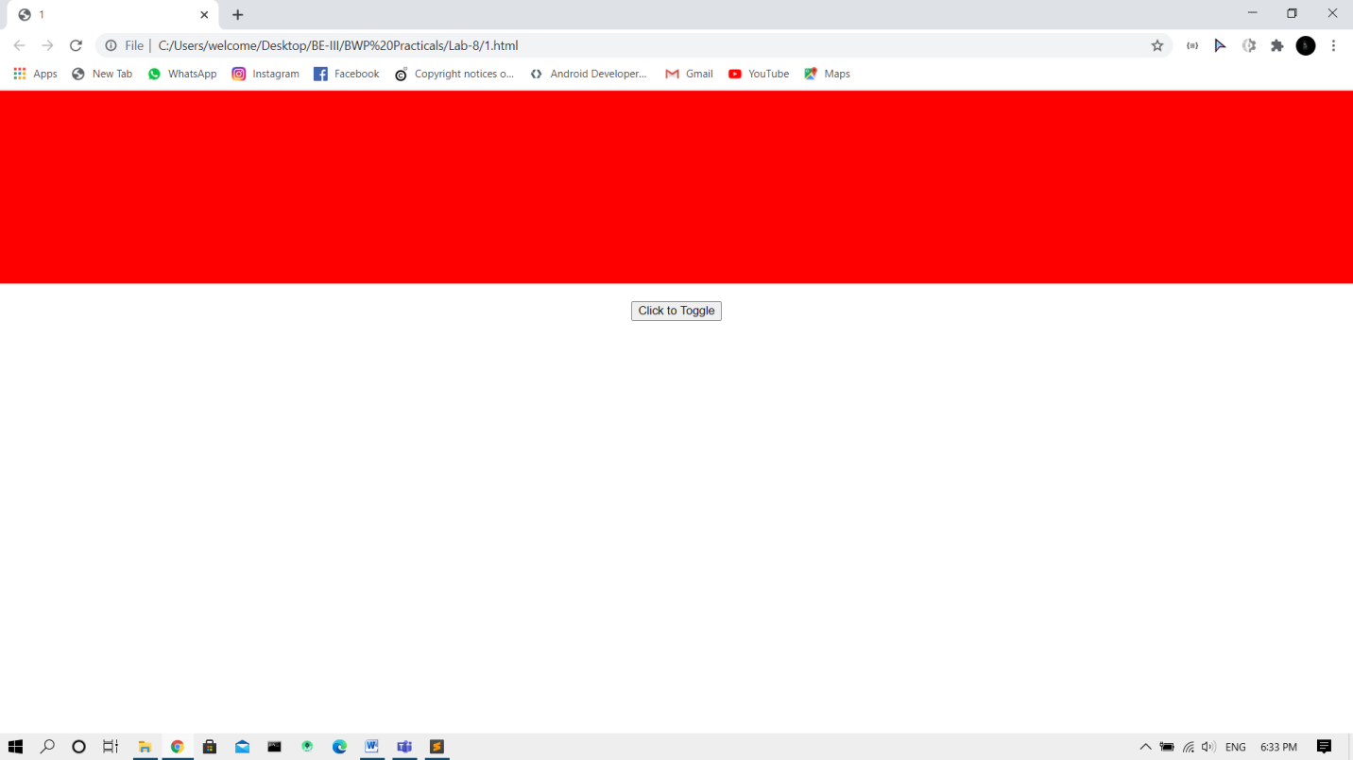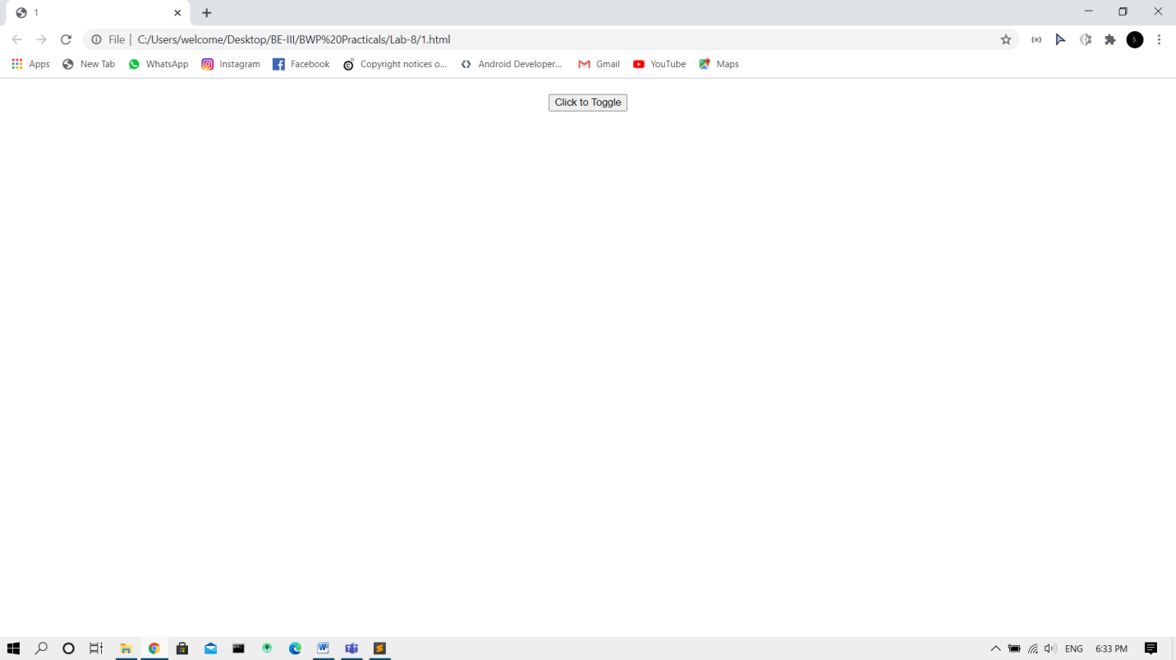

2-Use the animate() method to move a <div> element 250 pixels to the right.

Code:

<!DOCTYPE html>

<html lang="en">

<head>

<meta charset="UTF-8">

<meta name="viewport" content="width=device-width, initial-scale=1.0">

<title>2</title>

<script src="https://ajax.googleapis.com/ajax/libs/jquery/3.5.1/jquery.min.js"></script>

</head>

<body>

<div style="margin: 50px;background: red;width: 130px;height: 130px;position: relative;" id="hi">

</div>

<button onclick="move()">

Click to move div element 250px to right

</button>

<script>

function move(){

$('#hi').animate({left:'250px'},)

}

</script>

</body>

</html>

Output:

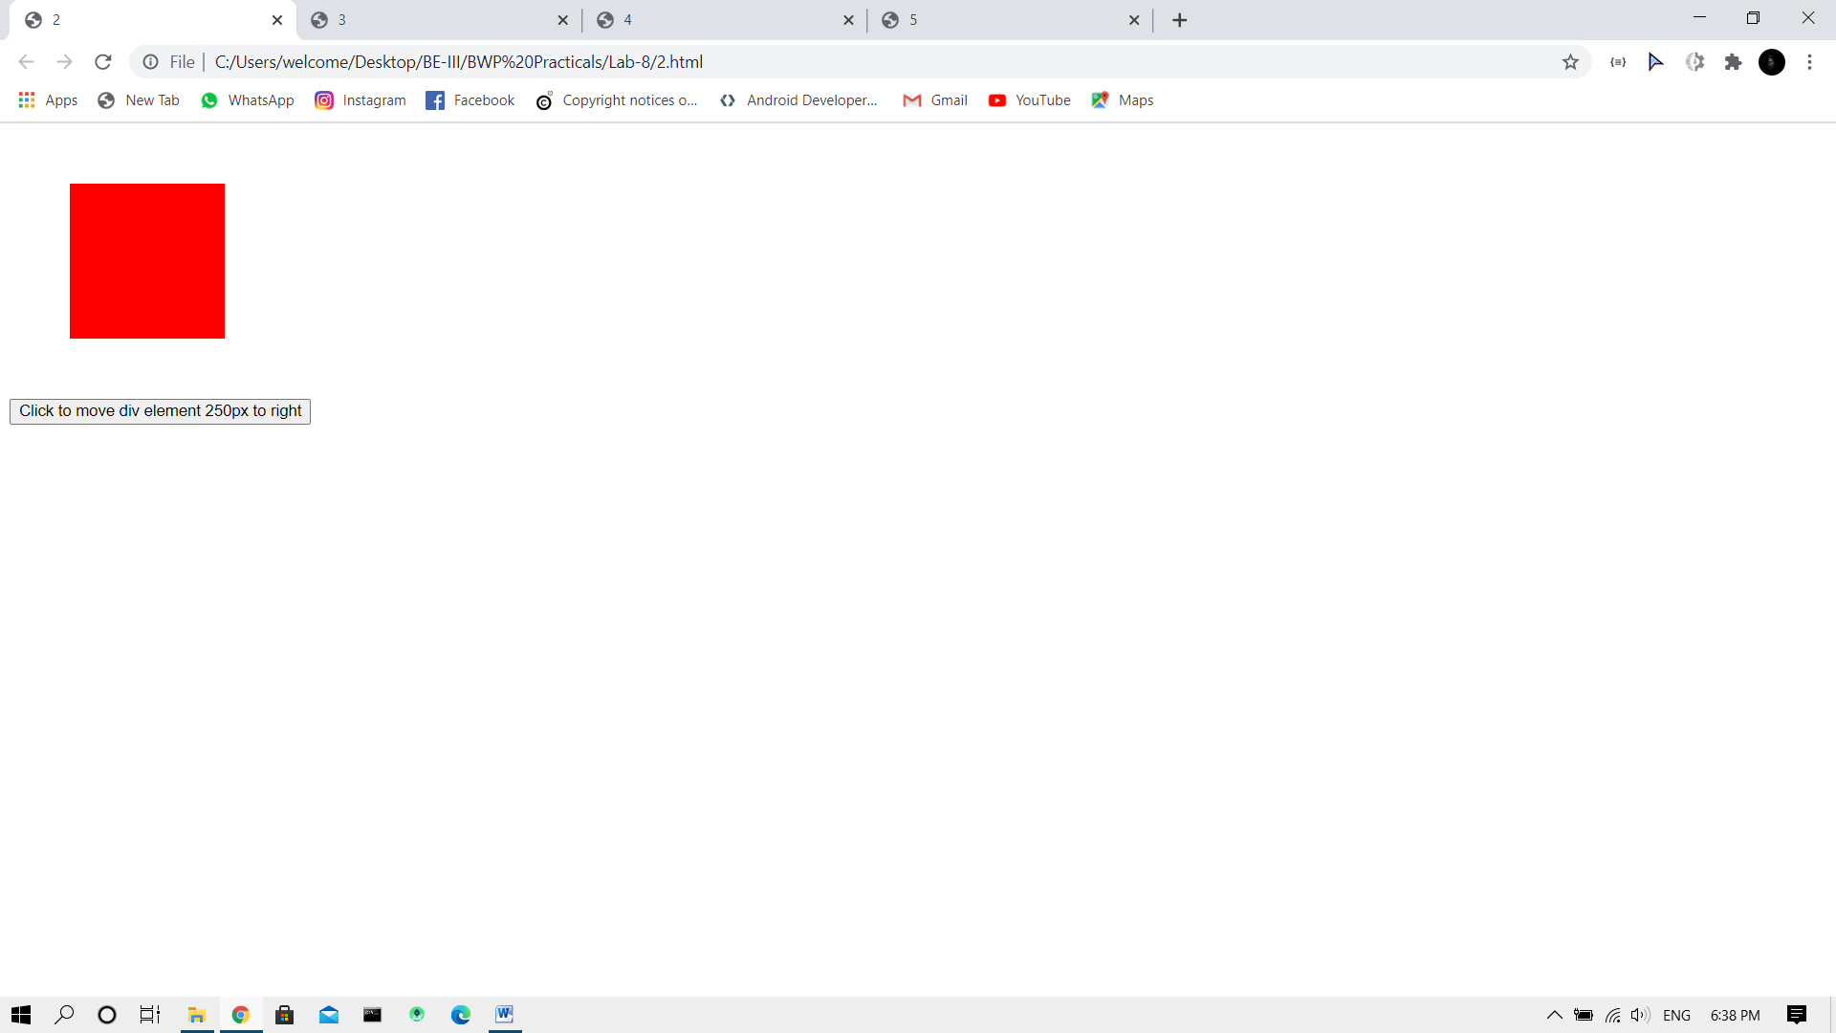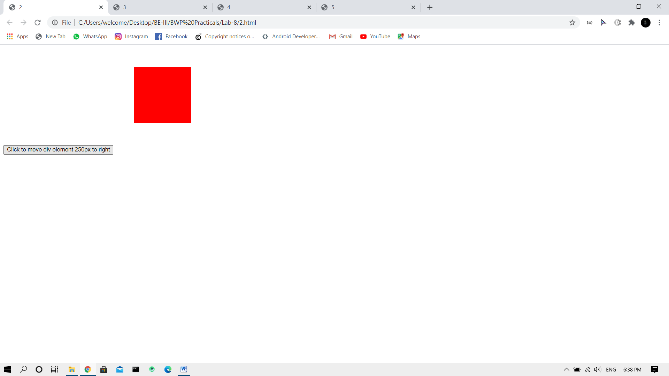

3-Use the animate() method to set the following CSS properties for <div>: opacity:0.4, height:500px, width:500px.

Code:

<!DOCTYPE html>

<html lang="en">

<head>

<meta charset="UTF-8">

<meta name="viewport" content="width=device-width, initial-scale=1.0">

<title>3</title>

<script src="https://ajax.googleapis.com/ajax/libs/jquery/3.5.1/jquery.min.js"></script>

</head>

<body>

<div style="margin: 50px;background: red;width: 130px;height: 130px;position: relative;" id="hi">

</div>

<button onclick="move()">

Click to apply opacity:0.4, height:500px, width:500px.

</button>

<script>

function move(){

$('#hi').animate({opacity:'0.4', height:'500px', width:'500px'})

}

</script>

</body>

</html>

Output:

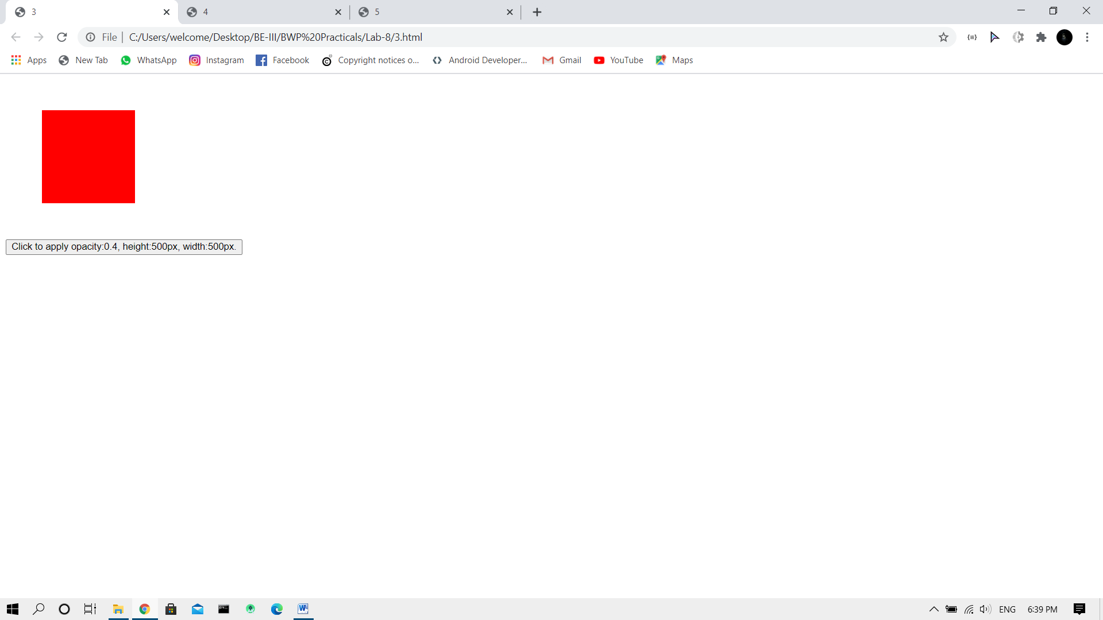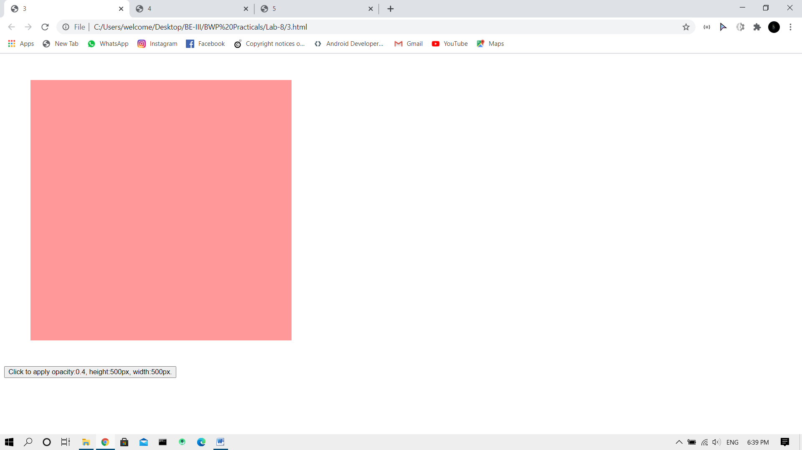

4-Use the animate() method to set the font-size of a <div> element to 100 pixels. The duration of the effect should be slow.

Code:

<!DOCTYPE html>

<html lang="en">

<head>

<meta charset="UTF-8">

<meta name="viewport" content="width=device-width, initial-scale=1.0">

<title>4</title>

<script src="https://ajax.googleapis.com/ajax/libs/jquery/3.5.1/jquery.min.js"></script>

</head>

<body>

<div style="margin: 50px;background: red;position: relative;padding: 30px;" id="hi">

<p style="color: white;">Lorem ipsum, dolor sit amet consectetur adipisicing elit. Deserunt nihil odio, non deleniti accusantium qui labore quo commodi debitis quidem velit aliquam laboriosam sequi repudiandae mollitia rem temporibus consectetur. Neque.</p>

</div>

<button onclick="move()">

Click to apply font-size of a div element to 100 pixels..

</button>

<script>

function move(){

$('#hi p').animate({fontSize:'100px'})

}

</script>

</body>

</html>

Output:

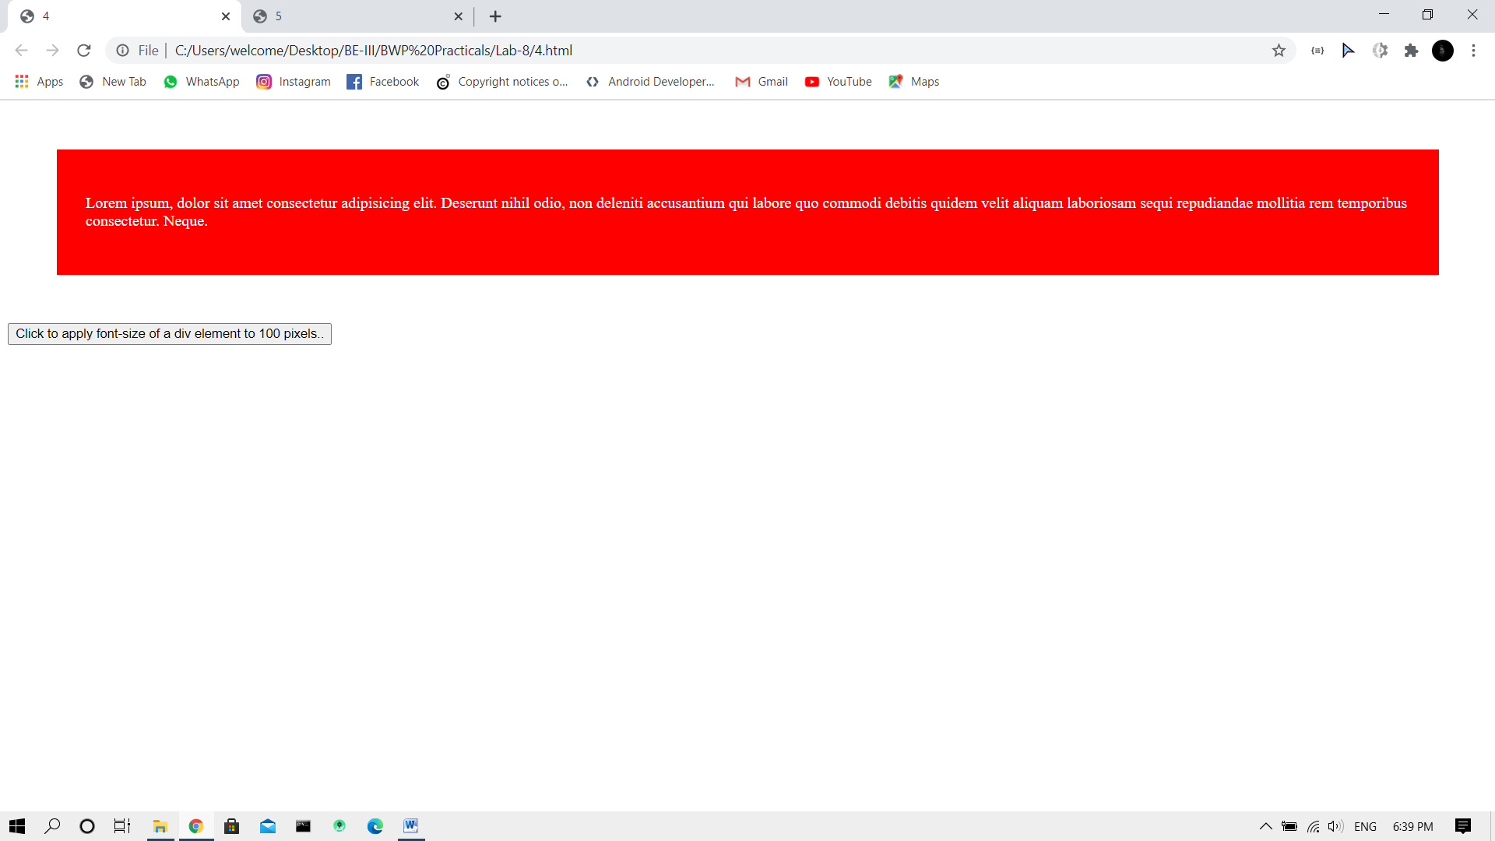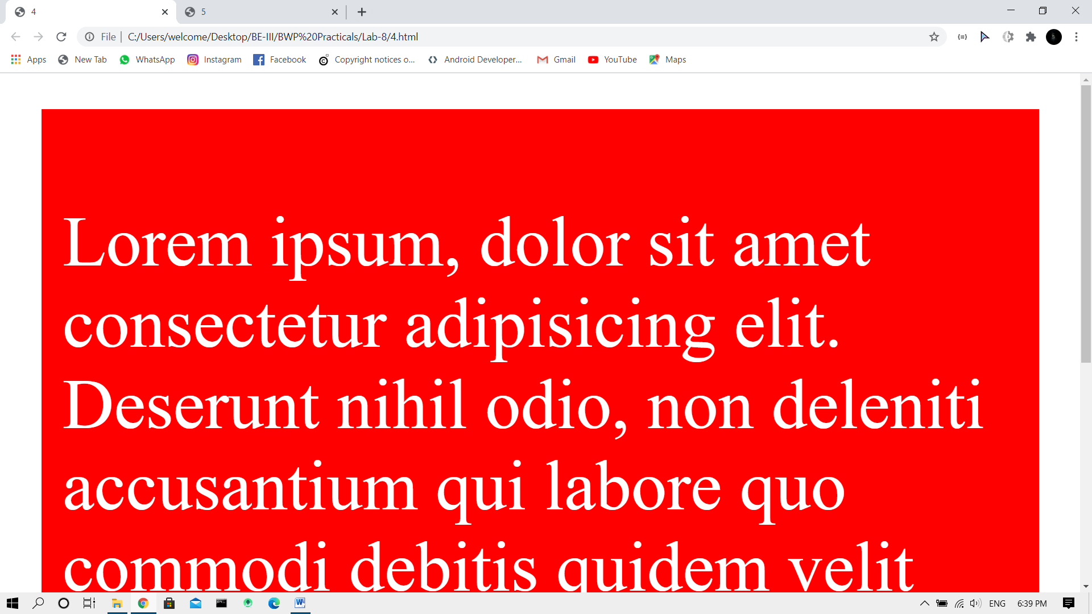

5-Create cartoon animation using jQuery.

Code:

<!DOCTYPE html>

<html lang="en">

<head>

<meta charset="UTF-8">

<meta name="viewport" content="width=device-width, initial-scale=1.0">

<title>5</title>

<script src="https://ajax.googleapis.com/ajax/libs/jquery/3.5.1/jquery.min.js"></script>

<style>

@keyframes walk{

0%{

background-position:0 0px;

}

100%{

background-position: 0 -600px;

}

}

@keyframes fly{

0%{

background-position: 0px;

}

100%{

background-position: -120px;

}

}

</style>

</head>

<body style="margin: 0;padding: 0;height: 100vh;overflow: hidden;" id="body">

<img src="ground.png" alt="" style="width: 100vw; bottom: 0;position: absolute;z-index: 999" id="ground">

<img src="sun.png" alt="" style="position: absolute;top: 50%;left:50%;transform: translate(-50%,-50%);z-index: 4" id="sun">

<img src="sun2.png" alt="" style="position: absolute;top: 50%;left:50%;transform: translate(-50%,-50%);" id="sun2">

<img src="sky.png" alt="" style="width: 100vw;height: 100vh;opacity: 1;position: absolute;" id="sky" >

<img src="clouds.png" alt="" style="position: absolute;" id="cloud">

<img src="stars.png" alt="" id="stars" style="opacity: 0">

<img src="moon.png" alt="" style="opacity: 0;top:100%;position: absolute;left:50%;transform: translate(-50%,-50%);z-index: 990" id="moon">

<p style="color: white;position: absolute;top:10%;left:50%;transform: translate(-50%,-50%);font-style: oblique;font-size: 30px;font-weight: bold;opacity: 0" id="text">Made By Rahul</p>

<div id="dog" style="background: url(ani.png);z-index: 100000;position: absolute;top: 90%;left:80%;width: 100px;height: 50px;animation: walk 2s steps(12) 10;background-repeat: no-repeat;background-size: 100px 600px;"></div>

<div style="position: absolute;background: url(bird.png);width: 30px;height: 30px;background-repeat: no-repeat;background-size: 120px 100%;animation: fly 0.5s steps(4) infinite;top:30%;left:30%;" id="f1"></div>

<div style="position: absolute;background: url(bird.png);width: 30px;height: 30px;background-repeat: no-repeat;background-size: 120px 100%;animation: fly 0.5s steps(4) infinite;top:20%;left:50%;" id="f2"></div>

<div style="position: absolute;background: url(bird.png);width: 30px;height: 30px;background-repeat: no-repeat;background-size: 120px 100%;animation: fly 0.5s steps(4) infinite;top:34%;left:80%;" id="f3"></div>

<div style="position: absolute;background: url(bird.png);width: 30px;height: 30px;background-repeat: no-repeat;background-size: 120px 100%;animation: fly 0.5s steps(4) infinite;top:10%;left:10%;" id="f4"></div>

<div style="position: absolute;background: url(bird.png);width: 30px;height: 30px;background-repeat: no-repeat;background-size: 120px 100%;animation: fly 0.5s steps(4) infinite;top:76%;left:24%;" id="f5"></div>

<div style="position: absolute;background: url(bird.png);width: 30px;height: 30px;background-repeat: no-repeat;background-size: 120px 100%;animation: fly 0.5s steps(4) infinite;top:70%;left:60%;" id="f6"></div>

<div style="background: url(fall.png);position: absolute;top: -10%;left: 0;z-index: 999999;width: 100px;height: 100px;background-repeat: no-repeat;background-size: 100%;opacity: 0.5;z-index: 995" id="fall"></div>

<script>

$('#sun').animate({top:'100%',opacity:'0'},10000)

$('#sun2').animate({top:'100%'},10000,function(){

$('#body').css('background','black')

$('#sky').animate({opacity:'0'})

$('#stars').animate({opacity:'1'},2000)

$('#moon').animate({opacity:'1',top:'50%'},10000,function(){

$('#fall').animate({opacity:'1',top:'100%',left:'80%'},5000)

$('#text').animate({opacity:'1'},2000)

})

})

$('#f1').animate({top:'-10%',left:'20%'},10000)

$('#f2').animate({top:'40%',left:'150%'},10000)

$('#f3').animate({top:'-10%',left:'80%'},10000)

$('#f4').animate({top:'60%',left:'110%'},10000)

$('#f5').animate({top:'-10%',left:'40%'},10000)

$('#f6').animate({top:'-10%',left:'100%'},10000)

$('#cloud').animate({left:'100%'},10000)

$('#dog').animate({left:'-10%'},20000)

</script>

</body>

</html>

Output:

